Database design
This document will explain the design of the database for the Sailing race manager web-app, and
explain the design choices.
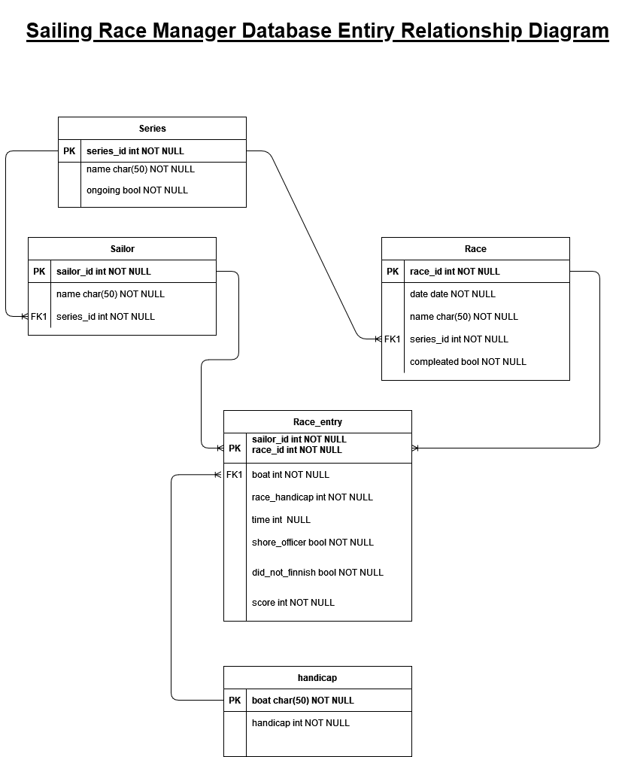Figure 1: Entity Relationship diagram version 1
Figure 1 shows the initial entity relationship diagram prior to implementation. The tables are as follows:
- Series contains series’ of races
  - The name attribute represents the user-entered name of the series. It is up to the user to know which is which in the case of non-unique names
  - The ongoing attribute represents if the series id still in progress. This should only effect the displaying of the series data.
- Race contains all the races. It is connected to Series by a many to one relationship
  - The attributes of race are quite self explanatory, with the completed attribute bing similar to the ongoing attribute in series, representing if a race has had all its results inputted.
- Sailor represents sailors. A sailor is unique to each series. This is to remove the need to an overall list of all sailors who have every been in a race. The user, can start a new series and not have to worry about any previous data. Sailors can be considered on a series by series basis. It also removes all coupling between series’ and, as sailors need to be manually entered into each series anyway, shouldn’t require much more effort on the user’s part.
- Handicap represents the handicaps of all boats that can be sailed
- Race entry represents a sailors entry in a race. It has a composite primary key made op of the Sailor_id and race_id attributes, as a race entry is a specific sailor is a specific race.
  - The boat attribute contains the boat that sailor is racing in in that race. Sailors can be in any boat in each race. It is mostly used to autocomplete the handicap attribute with reference to the handicap table.
  - The time attribute contains the time the sailor took to complete the race. It can be null in the cases the sailor did not complete in or sail the race
  - The shore officer and did not finish attributes indicates reasons why the sailor did not compete in the race that effect score calculation.
  - The score attribute contains the sailors score for the purposes of displaying the leader-board. It is automaticity calculated form the other fields.

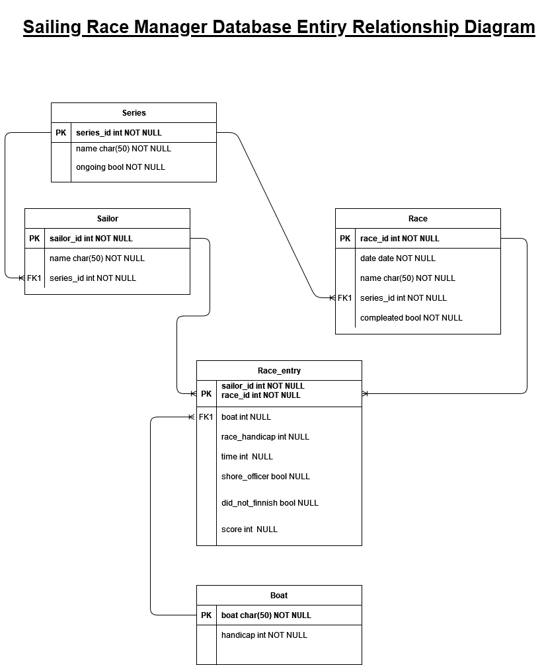Figure 2: Entity Relationsip Diagram Version 2
Figure 2 shows an updated version of the ERD. The differences are as follows
- Renaming of Handicap table to boat to better portray what it represents
- Allowing most of the Race_entry attributes to be null to enable the web-app to better manage the entries. For example, all entries for a race will be auto-created when a race is added, but most of the data will not be available yet. Also, score depends on ranking of time in a race, so cannot be added until race is marked complete.

